Lecture 10
CHEMISTRY OF LIPIDS
INTRODUCTION
Lipids are another important class of macro molecule found in all living cells. They are the only macromolecule without a specific monomeric units. The word lipid was derived from Greek word lipos, the meaning of lipos in greek is fats. This is why lipid and fat are used interchangeably in many literatures. Lipids are described as a group of heterogeneous compounds that are not readily soluble in water or polar solvents but are readily soluble in organic solvents such as chloroform, hydrocarbons etc. Examples of lipids include fats, oils steroids, waxes and related compounds. Lipids are usually hydrophobic or amphipathic molecules, the most common lipids in nature consist of fatty acids linked by an enter bond to glycerol or to other alcohol such as cholesterol. In addition to fatty acids and alcohol they may contain other compounds such as phosphoric acid, organic bases and carbohydrates. All the components of lipids can be released or separated by various hydrolytic procedures.
The study of lipid biochemistry is important for thorough understanding of causes, effects and management of metabolic disorders of lipid metabolism such as obesity and cardiovascular diseases. Measurement of lipoproteins and cholesterol in the blood can serve as early warning for impending danger to our health.

Biological Functions of Lipids
Lipids have various important functions in animals, some of the functions are:
i. Lipids are important dietary constituents of food and have high energy value.
ii. Dietary lipids are the sources of fat soluble vitamins and essential fatty acids. They also help in transportation of many water insoluble molecules.
iii. Lipids serve as energy stores, fats stored in animals as triacylglycerol or triglyceride in the adipose tissue is a potential source of energy.
iv. Fats present in the subcutaneous tissues act as an insulating material.
v. Lipids are important component of plasma membranes.
vi. Lipids are involved in various intra and intercellular signaling processes.

Classification of Lipids
Lipids are classified into three groups based on the number and types of components present in the lipid. The three groups are simple lipids, complex or compound lipids and derived lipids.

Simple Lipids
They are the simplest form of lipids and the ester of fatty acids with various types of alcohols. When simple lipids are hydrolysed, they yield just two types of products. (Fatty acids and alcohol or glycerol).
Examples of simple lipids are fats, oils and waxes.
(a) Fats – Fats are solid at room temperature because their fatty acids are saturated. Fats are obtained naturally from animal sources; example of natural fats is lard. Butter and margarine are artificial fats produced by hydrogenation of oils (conversion of unsaturated).
Fats play vital role in maintaining healthy skin and hair, insulating body organs against shock and maintaining body temperature. In animals, fats are stored in the white adipose tissue, or fatty tissue. Adipocyte store fat derived from the diet and those derived from metabolism in the liver.
Visceral fat is located within the abdominal wall i.e. beneath the wall of abdominal muscle) whereas subcutaneous fat is located beneath the skin.

(b) Oils- Oils are liquid lipids at room temperature due to the presence of unsaturated fatty acids. Oils are obtained from plant seeds or through the melting of animal fats.

(c) Waxes - They are also solid at room temperature due to the presence of saturated fatty acids and high molecular weight monohydric alcohol.

Complex Lipids
Complex lipids contain other amphipathic compounds in addition to fatty acids and alcohol present in simple lipids. The compounds include phosphoric acid, various sugars, sphingosine, ethanolamine and serine.
Generally, complex lipids yield three or more primary products when they are hydrolysed. Examples of complex lipids include phospholipids, glycolipids and sphingolipids. Sphingophospholipids are made up of fatty acids, sphingosine, phosphoric acid and choline.
Sulpholipids (sulphur containing lipids), and lipoproteins also belong to the group of complex lipids.

Derived Lipids
These lipids are derived from the hydrolysis of simple and complex lipids. They are mainly fatty acids, glycerols and steroids or sterols.
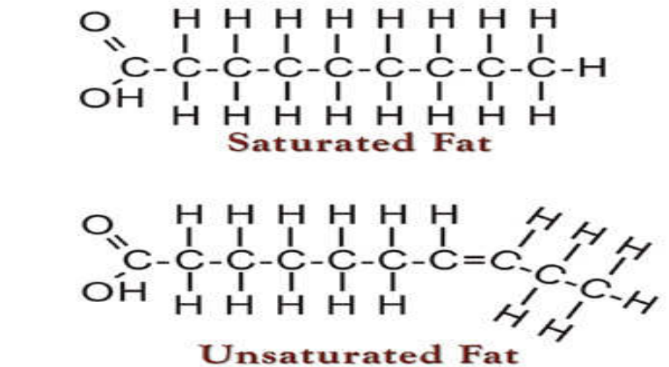
Figure 1: Chemical Structures of Fatty Acids.

Fatty Acids
Fatty acids are the carboxylic acids with a long hydrocarbon chain. Fatty acids in animals occur mainly as esters in natural fats and oils (they exist as components of triglycerides)
Fatty acids occur as free fatty acids in the plasma where it acts as transporter of various biological molecules, especially plasma albumin.
Fatty acids that occur in natural fats usually contain an even number of carbons between 11 and 24 carbon atoms. The 16 and 18 carbon fatty acids are the most common FA in animals. They may be saturated or unsaturated.
(a) Saturated fatty acids
Saturated fatty acids are the fatty acids without double bonds, examples of such fatty acids are palmitic acid (C16), stearic acid (C18) and arachidonic acid (C20). Palmitic acid, myristic acid and stearic acid are the most abundant saturated fatty acids in human. Lauric acid (C12) is present in coconut oil.

Unsaturated fatty acids are the FA that contains one or more double bonds. Unsaturated FA can be divided into three groups based on the number of double bonds present. Most naturally occurring unsaturated FAs have a cis-configuration i.e. the hydrogen atoms are on the same side of the chain while FAs containing trans-double bonds (hydrogen atoms are on the opposite sides) are found in small amounts in natural fats and in greater amounts after processes involving catalytic hydrogenation.
1. Monounsaturated Fatty Acids (MUFA): They contain only one double bond. Oleic acid is the most abundant monounsaturated FA in nature, Palmitoleic acid is another example of MUFA, and it is present in nearly all fats.
2. Polyunsaturated fatty acids (PUFA) – These are the FAs obtained from plant seeds. They usually contain 2 or more double bonds.
In PUFA, double bonds are usually separated by a methylene (CH₂) group. PUFA are present in oils such as soya bean oil, groundnut oil, sunflower, benin-seed oil etc. Examples of PUFA are linoleic and linolenic acids; they are also called omega 6 and omega 3 FAs respectively. These two PUFA are also referred to as essential PUFA (EFA). They are essential because animals cannot synthesize them, therefore they must be supplied to the body in the diet.
3. Linolenic acid– it is known as omega-3 fatty acid (ω3): Why are these two PUFAs essential to animals? Linoleic and linolenic fatty acids are the biosynthetic precursors of 20 and 22 carbons polyunsaturated FAs, with 3 to 6 double bonds. Enzymes which insert double bonds into unsaturated fatty acids are known as desaturases. Desaturases in animals can insert a double bond on the carboxyl side of existing double bonds only, they are called Δ⁹ desaturases. Δ⁹ desaturases are the only desaturase present in animals; hence they can synthesize only oleic acid and members of its family. The FAs derived from linoleic acid, especially arachidonic acids, are the precursors of the prostaglandins and steroids.

Symptoms of essential fatty acids deficiency
When essential fatty acids (omega-3 and omega-6 fatty acids) are not present in our diets, our body will not be able to produce prostaglandins and sterols (this is just one of many functions of these FA). We know that hormones are very important for reproduction in man and woman, deficiency of material required to synthesise them will result in inadequate or complete absence of the hormones. The result is infertility.
So, foods that are rich in essential fatty acids are good for our health, examples of such foods are fish, poultry products, fruits, vegetables, nuts (especially walnuts), legumes (especially soya beans), beef etc. The symptoms of essential fatty acids deficiency are:
i. Growth retardation
ii. Poor wound healing
iii. Dermatitis, and hair loss
iv. Kidney and liver diseases
v. Infertility
vi. Depression
The most noticeable symptoms of EFA deficiency are skin disorders such as scaly dermatitis. It can show up another on the body, but usually occur on the hands, shoulders, forearms and face. When EFA are included in the diets, these symptoms disappear within 7 days.

Eicosanoid
The third group of unsaturated FA is the family of PUFA known as eicosanoids. The eicosanoids are a complex family of bioactive lipid messengers, generated by oxygenation of 20-carbon polyunsaturated fatty acids, primarily arachidonic acid. Eicosanoids are local-acting hormones that stimulate cells adjacent to their site of synthesis. In general, eicosanoids have a short half-life, usually on the order of minutes. They are not stored in cells but instead are released as soon as they are synthesized. Eicosanoids fall into two main classes;
i. Prostanoids that have a ring structures including prostaglandins, thrombaxanes and prostacyclins.
ii. Linear eicosanoids consisting of leukotrienes, lipoxins and hydroxyl eicosatetraenoid acids (HETE).

Prostaglandins
Prostaglandins exist in virtually every mammalian tissue. They are synthesized from arachidonic acid. Prostaglandins act to modulate many physiological functions including blood pressure, contraction of uterus, and inflammatory signals. Prostaglandins are designated PGA, PGD, PGE and PGF based on the functional groups on the cyclopentane ring.
Prostaglandin H₂ and prostacyclin are synthesized from PG H₂.
Leukotrienes and lipoxins are linear eicosanoids unlike the prostanoids, which contain a ring in their structure, the leukotrikenes are linear molecules. The terms leukotriene was derived from their cell of origin (Leukocytes) and the fact that their structures contain three carbon-carbon double bonds in conjugation. The most important Leukotrienes in humans are: LTA₄ and LTB₄.

Triacylglycerols
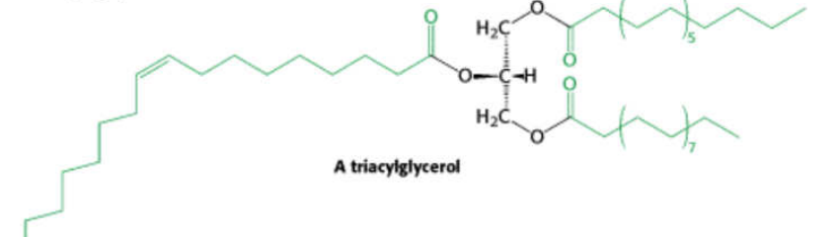
Figure 2: Structure of Triacylglycerol.
Triacylglycerols are esters of the alcohol called glycerol and fatty acids.
They represent the major form of fat found in nature and their primary function is to provide energy for the cell. The cell degrades fatty acids to CO₂ and water at the expense of molecular oxygen. One gram of fatty acid liberates about 9 kilocalories (38 KJ) of energy, this is about 2.5 times higher than that of the other foodstuffs i.e. protein and carbohydrate which yield about 4 kilocalories/g (17KJ) when catabolized. The human body stores large amounts of fatty acids as triglyceride in adipose tissue, and this is the storage form of energy in all animals. Fatty acids in the form of triglycerides are in anhydrous form, whereas, carbohydrates and proteins are stored in an aqueous environment. It is evident that, in terms of the energy to mass ratio, fat is a much more efficient means of storing energy than carbohydrate or protein. Mammalian tissues also contain some diglycerides and monoglycerides, but they occur in very small quantity when compared with triglycerides.
Naturally occurring fats and oils develop unpleasant smell and taste if stored for long under moist conditions, the chemical reaction responsible for the odour and taste as called rancidity. Rancidity is due to partial hydrolysis of TAG and the subsequent oxidation of the hydrolysed fatty acids to aldehyde and ketone.

Steroids
Cholesterol is a monohydric alcohol; it is classified as a derived lipid because it is a component of other complex lipids. It is also a precursor of two important classes of molecules; bile acids and steroid hormones; cholesterol is probably the best-known steroid because of its association with atherosclerosis and heart disease.
All steroids have a similar cyclic nucleus resembling phenanthrene (rings A, B and C) to which a cyclopentane ring ∆ is attached.
The five classes of steroids are
i. Glucocorticoids
ii. Minerals corticoids 21- carbon structures
iii. Progesterone
iv. Testosterone 19 carbon structure
v. Androgens

Bile acids or bile salts play a major role in the digestion and absorption of triacylglycerols and cholesterolyl esters. Formation of bile salts represents the only significant metabolic mechanism for eliminating excess cholesterol from the body.

Lipoproteins
Lipids are not soluble in aqueous solution such as the blood. Since lipids are not soluble in water, how are they transported in the body? This problem was solved by the presence of a lipid carrier called lipoproteins.
Lipoprotein is made up of lipid and protein in such a way that the lipids components are packed at the center while the protein components serve as the coat. The lipoprotein coat also contains amphipathic molecules such as phospholips, cholesterol, and specially synthesized protein called apoproteins. The polar ends of the amphipathic lipids face the surface of the particles, while the hydrophobic portions are oriented towards the centre of the particle.
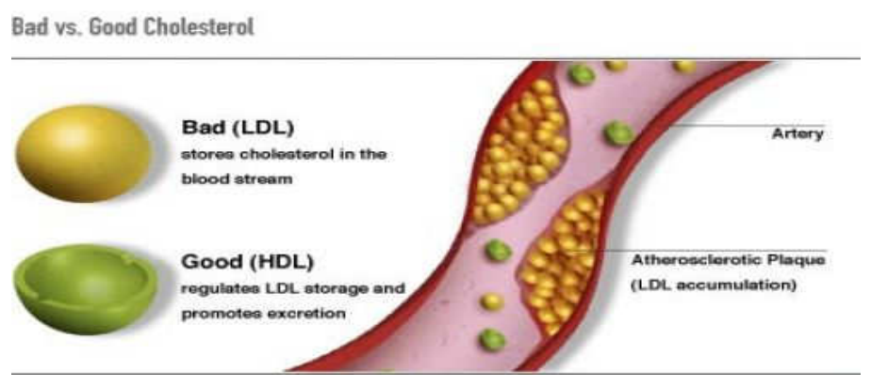
Figure 3: Effects of LDL and HDL on the Artery.

Classification of lipoproteins
i. High Density Lipoprotein (HDL): The most dense lipoprotein class is called high density lipoprotein. It contains about 50% lipids and 50% protein. The major function of HDL is to collect cholesterol from peripheral tissues and transport it back to the liver where it is converted to bile acids and excreted. This function is referred to as reverse cholesterol transport (RCT).
HDL is usually referred to as good cholesterol because of its ability to reduce the body’s cholesterol content; high concentration of HDL in the blood is good for the prevention of cardiovascular diseases.
ii. Low Density Lipoproteins (LDL): They are cholesterol rich particles, LDL carries about 75% of the total cholesterol in human plasma. Its major function is the transport of cholesterol to various extrahepatic tissues. They are usually referred to as bad cholesterol because of their role in cholesterol distribution to body cells. So, low concentration of LDL in the plasma is beneficial to the body than high concentration.
iii. Very low Density lipoprotein (VLDL): They are secreted to the blood plasma by the hepatocytes. Only 50-60% of their mass is triacylglycerols and they contain relatively more cholesterol esters than the chylomicrons.
iv. Chylomicrons: These particles have the lowest density among the lipoproteins. About 90% of their mass is made up of triglyceride, cholesterol esters and free cholesterols.

Physical Properties of lipids
- Lipids are soluble in non-polar solvents, such as ether, alcohol, chloroform, acetone, and benzene.
- Lipids are insoluble in water.
- Lipid molecules have no ionic charges.
- Pure fats and oils are colorless, odorless, and tasteless.
- Lipids are considered hydrophobic or amphiphilic small molecules.
- Lipids are greasy in texture and stored in adipose tissues inside the body.
- Lipids are either liquid or non-crystalline solid at room temperature.
- Lipids can either be present in saturated (having only single bonds) or unsaturated (having one or more double bonds) structural form.

Chemical Properties of lipids
Hydrolysis - Triacylglycerols undergo stepwise enzymatic hydrolysis to finally liberate free fatty acids and glycerol. The process of hydrolysis, catalyzed by lipases is important for digestion of fat in the gastrointestinal tract and fat mobilization from the adipose tissues.
Saponification - The hydrolysis of triacylglycerols by alkali to produce glycerol and soaps is known as saponification.
Rancidity - Rancidity is the term used to represent the deterioration of fats and oils resulting in an unpleasant taste. Fats containing unsaturated fatty acids are more susceptible to rancidity.
Lipid Peroxidation - In the living cells, lipids undergo oxidation to produce peroxides and free radicals which can damage the tissues. The free radicals are believed to cause inflammatory diseases such as cancer, artherosclerosis, ageing etc.
Halogenation - Unsaturated fatty acids, whether they are free or combined as esters in fats and oils, react with halogens by addition at the double bond(s). The reaction results in the decolorization of the halogen solution.

